A

A PROJECT REPORT

Cafe selling store

Submitted to

Department of Information Technology DIPLOMA OF ENGINEERING

SHREE SWAMINARAYAN POLYTECHNIC

SECTOR – 22, Gandhinagar – 382022.

Gujarat Technological University Ahmedabad
2024-2025





CERTIFICATE

Date:

This is to certify that the dissertation entitled “Cafe selling store” has been carried out by Monika thakar under my guidance in fulfilment of the Diploma of Engineering in “Information Technology” (6th Semester) of Gujarat Technological University, Ahmedabad during the academic year 2024-25.

Internal Guide: Monika Thakar Head of Department:

Gujarat Technological University Chandkheda

A
Project report on
“Cafe store”
Submitted by,
Patel Rishi 229860316072

As a part of my project work for the current academic term 2024-25, I have taken guidance and support
from Sapphire web Works, receiving valuable insights and assistance throughout the development process.

Project Guide: Monika Thakar External examiner:

Date: Date:

Acknowledgment
I would like to acknowledge the contribution of certain distinguished people; without their support and guidance this project work would not have been completed.
I take this opportunity to express my sincere thanks and deep sense of gratitude to my project internal guide and Head of the Sapphire Webworks for his guidance and moral support during preparation of this project report. I really thank him from the rock bottom of my heart for always being there with his extremeknowledge and kind nature.
I take this opportunity to thank all my friends and colleagues who started me out on the topic and provided extremely useful review feedback and for their all-time support and help in each and everyaspect of the course of my project preparation. I am grateful to my college Shree Swaminarayan Polytechnic.

Cafe store

- At Caféry, we believe that every cup of coffee tells a story and every meal is a moment to savor. Located in the heart of the city, our café is a cozy retreat where exceptional flavors meet a warm, inviting atmosphere. Whether you're in the mood for a rich espresso, a perfectly brewed tea, or a deliciously crafted meal, Caféry is here to offer you an unparalleled experience.
- Explore our diverse menu, featuring artisanal coffee blends, freshly baked pastries, and wholesome, gourmet dishes made with the finest ingredients. Our commitment to quality and service ensures that each visit to Caféry is not just a stop for coffee but a delightful escape from the everyday hustle.
- Join us at Caféry, where every visit is a celebration of taste and tranquility. We look forward to sharing our passion for great food and great company with you!

ii

Cafe store

LIST OF FIGURES

Figure No
1

Figure Description
System Design

Page No
16

- DFD Symbols 17
- DFD Level (0) 18
- DFD Level (1) 19
- ER-Diagrams Symbols 10
- ER-Diagram of Coffestore 21
- Use case diagram 22
- Use Case Diagram Symbols Notation 22
- Use Case Diagram of Admin and user 23
- Activity Diagram UML Notations 24
- Example of Class Diagram 29
- Class Diagram of Coffee store 30

iii

Chapter 1 | Introduction | 1
 | 1.1 Introduction | 2
 | 1.2 Problem Introduction | 4
 | 1.3 Modules of Projects | 5
Chapter 2 | Requirements And Specifications | 6
 | 2.1 Hardware Requirements | 7
 | 2.2 Software Requirements | 8
Chapter3 | Analysis | 9
 | 3.1 Existing Systems | 10
 | 3.2 Proposed System | 10
 | 3.3 Feasibility Study | 10
 | 3.4 Software Specifications Requirements | 11
 | 3.5 JavaScript | 13
Chapter 4 | Design | 14
 | 4.1 System Diagram | 15
 | 4.2 Data Flow Diagram | 16-18
 | 4.3 ER-Diagram | 19-20
 | 4.4 Use case Diagram | 21-25
 | 4.5 Class Diagram | 29-30
Chapter 5 | Data Dictionary | 31
 | 5.1 Data Dictionary Tables | 33-39
Chapter 6 | Screenshot's | 41
Chapter 7 | Conclusion | 55

INTRODUCTION

Creating an engaging and functional online store is a multifaceted process that involves careful planning, design, and implementation. Cafery, hosted https://cafery.odoo.com/, is the result of a comprehensive development journey aimed at establishing a seamless platform for selling premium timepieces. This report outlines the steps and strategies involved in bringing this e- commerce website to life.

The development of Cafery began with a clear vision: to create an online destination that combines aesthetic appeal with robust functionality. The process involved selecting the right platform, designing a user-friendly interface, and ensuring the website's backend could support efficient operations, including inventory management, order processing, and customer engagement. Key elements of the project included the integration of a secure payment gateway, the design of intuitive navigation, and the implementation of responsive design principles to ensure compatibility across various devices. Additionally, we focused on optimizing the website for performance and search engine visibility, ensuring that our customers can easily find and enjoy a smooth shopping experience.

In this report, we will detail the technical and creative processes involved in the website's development, including the tools and technologies used, challenges encountered, and the solutions implemented to create a polished and professional online store.

Project Profile

Project Definition | Cafe store
Category | Website
Team Member | Patel Rishi
Team Size | 1
Internal guide | Monika Thakar
Technology Used | PHP
Tools | Dreamweaver
Front End | Html, CSS
Back End | PHP web services with MySQL
Operating System | Windows 11
Collage Name | Shree Swaminarayan Polytechnic
    - Project Summary

- We have designed a website that can perform different functionalities.
- Some of the highlights of our application simple and easy to use Efficient functioning: capable of producing a result

Purpose: Goals & Objectives

Goals:
      - Main goal of this system is to provide simple interface for Cafe store.
      - Our store provides authenticate watches

Objectives:
      - The Project is developed using HTML, CSS, PHP & JavaScript as a programminglanguage and SQL database tools are used.

Problem Introductions

Developing Cafery at website came with several challenges common to e-commerce websites. Creating a user-friendly interface that works seamlessly across all devices required extensive testing and design adjustments. Integrating secure payment gateways was also crucial to protect customer data and ensure smooth transactions.

Managing the inventory and product database posed challenges in maintaining accurate stock levels and up-to-date product information. Additionally, balancing search engine optimization (SEO) with a visually appealing design was necessary to boost visibility while providing a great user experience.

These challenges demanded careful planning, technical expertise, and ongoing optimization to ensure the website’s success.

Modules of projects
    - Admin

### 1. **User Interface (UI) Module**: Designs and ensures the website is visually appealing and responsive across devices.

### 2. **Product Management Module**: Manages the addition, organization, and inventory of products.

### 3. **Customer Management Module**: Handles customer information, profiles, and authentication processes.

### 4. **Order Processing Module**: Manages the entire order lifecycle, from cart to checkout and confirmation.

### 5. **Payment Gateway Module**: Processes secure payments through integrated payment providers.

### 6. **Shipping and Logistics Module**: Manages shipping options, cost calculations, and tracking of orders.

### 7. **Review and Rating Module**: Collects, moderates, and displays customer reviews and ratings on products.

### 8. **Search and Navigation Module**: Facilitates product discovery through search and category navigation.

### 9. **SEO and Analytics Module**: Enhances site visibility on search engines and tracks user behavior and traffic.

###10. **Admin and Dashboard Module**: Provides a central interface for managing content, orders, and reports.

User module

The **User Module** manages user registration, login, profiles, and.



Chapter:2 REQUIREMENTS SPECIFICATIONS
- **Functional Requirements**: Implement user registration, product catalog management, secure checkout, and order processing.
- **Non-Functional Requirements**: Ensure fast performance, high security, scalability, and user- friendly design.
- **Technical Requirements**: Python, JavaScript, PostgreSQL, and integrate payment and shipping services.
- **Operational Requirements**: Schedule maintenance, provide user support, monitor performance, and manage content updates efficiently.

Hardware Requirements
    - 1. **Server Specifications**: A cloud server with at least 4 CPU cores, 8GB RAM, and 100GB SSD storage for hosting the website and database.
    - 2. **Network Requirements**: A high-speed internet connection with a reliable bandwidth of at least 1 Gbps for optimal performance and handling traffic.
    - 3. **Backup Storage**: External storage or cloud backup solution with at least 500GB capacity for regular data backups and disaster recovery.
    - 4. **Security Hardware**: A dedicated firewall and security appliances to protect the server from unauthorized access and cyber threats..

Hardware Requirements for this project

      - 1 Gigahertz Processor
      - 2 GB ram
      - 10gb hard disk

Software Requirements

- **Operating System**: Linux-based OS (e.g., Ubuntu Server) for hosting the website and running web services.
- **Web Server**: Nginx or Apache for managing HTTP requests and serving web content.
- **Database**: PostgreSQL for efficient management and storage of product, user, and order data.
- **Programming Languages**: Python for backend development, JavaScript for frontend interactivity, and XML/QWeb for templating.
- **Payment Gateway Integration**: APIs from providers like PayPal, Stripe, or similar for secure payment processing.
- **SSL Certificate**: To ensure secure data transmission through HTTPS.
- **Version Control**: Git for tracking code changes and managing versions.

Required Software

To create, run, and debug your PHP projects you need the following software:

      - A web server. Typically development and debugging is performed on a local web server, while the production environment is located on a remote web server. The current version enables using a local server. Using a remote server with FTP access will be supported in future versions. PHP support can be added to a number of web servers (IIS, Xitami, and soon), but most commonly Apache HTTP Server is used.
      - The PHP engine. The supported version is PHP5.
      - The PHP debugger. The NetBeans IDE for PHP allows you to use XDebug, but using a debugger is optional. The recommended version is XDebug 2.0 or higher as it is compatiblewith PHP5.
      - A database server. You can use various database servers while one of the most popular onesis the MySQL server.
      - OPERATING SYSTEM: Windows 7/ XP/8/10, Android.
      - FRONT END: HTML, CSS, Java Script.
      - SERVER-SIDE SCRIPT: PHP.
      - DATABASE: MySQL.



Chapter:3 ANALYSIS 3.1Existing Systems
- The existing system includes a responsive user interface, product management, and secure order processing. It manages customer accounts and integrates with shipping services for order fulfillment. Security features protect user data, while analytics track performance. Admins can easily update content and product information.

Proposed System
    - The proposed system will feature an enhanced user interface for improved responsiveness and design. It will include advanced product management capabilities and streamlined, secure order processing. The system will offer enhanced customer account management and better integration with shipping services. Improved security measures will safeguard user data, and advanced analytics will provide deeper insights into performance. Content management will be more intuitive for admins..

Feasibility Study
    - The feasibility study confirms that the proposed system is viable, with technical solutions aligning with current technology standards. Financially, the project is within budget, with a clear return on investment. Operationally, the system enhances user experience and efficiency, while the timeline for implementation is realistic. The proposed enhancements are expected to meet business goals and user needs effectively.

Technical Feasibility
      - This study is carried out to check the technical feasibility, that is, the technical requirementsof the system.
      - The developed system must have a modest requirement, as only minimal or null changes forthe implementing this system.
10

Software specifications requirement
    - HTML or Hypertext Markup Language is the standard markup language used to create web pages.
    - HTML is written in the form of HTML elements consisting of tags enclosed in angle brackets (like <html>).
    - HTML tags most commonly come in pairs like <h1> and </h1>, although some tags represent empty elements and so are unpaired, for example <img>.
    - The first tag in a pair is the start tag, and the second tag is the end tag (they are also called opening tags and closing tags).
    - The purpose of a web browser is to read HTML documents and compose them into visible or audible web pages.
    - The browser does not display the HTML tags, but uses the tags to interpret the content of the page. HTML describes the structure of a website semantically along with cues for presentation, making it a markup language rather than a programming language.
    - HTML elements form the building blocks of all websites.
    - HTML allows images and objects to be embedded and can be used to create interactive forms.
    - It provides a means to create structured documents by denoting structural semantics for text such as headings, paragraphs, lists, links, quotes and other items.

CASCADING STYLE SHEETS (CSS)
      - It is a style sheet language used for describing the look and formatting of a document written in a markup language.
      - While most often used to style web pages and interfaces written in HTML and XHTML, the language can be applied to any kind of XML document, including plain XML, SVG and XUL.
      - CSS is designed primarily to enable the separation of document content from document presentation, including elements such as the layout, colors, and fonts.
      - This separation can improve content accessibility, provide more flexibility and control in the specification of presentation characteristics, enable multiple pages to share formatting, and reduce complexity and repetition in the structural content.
      - CSS can also allow the same markup page to be presented in different styles for different rendering methods, such as on-screen, in print, by voice (when read out by a speech-based browser or screen reader) and on Braille-based, tactile devices.
      - It can also be used to allow the web page to display differently depending on the screen size or device on which it is being viewed.

MySQL
      - MySQL is developed, distributed, and supported by Oracle Corporation.
      - MySQL is a database system used on the web it runs on a server.
      - MySQL is ideal for both small and large applications.
      - It is very fast, reliable, and easy to use.
      - It supports standard SQL.
      - MySQL can be compiled on a number of platforms.
      - The data in MySQL is stored in tables.
      - A table is a collection of related data, and it consists of columns and rows.
      - Databases are useful when storing information categorically.

FEATURES OF MySQL
        - Internals and portability
          - Written in C and C++.
          - Tested with a broad range of different compilers.
          - Works on many different platforms.
          - Tested with Purify (a commercial memory leakage detector) as well as with Val grind, a GPL tool.
          - Uses multi-layered server design with independent modules.

Security
          - A privilege and password system that is very flexible and secure, and that enables host- based verification.
          - Password security by encryption of all password traffic when you connect to a server.

Scalability and Limits
          - Support for large databases. We use MySQL Server with databases that contain 50 million records. We also know of users who use MySQL Server with 200,000 tables and about 5,000,000,000 rows.
          - Support for up to 64 indexes per table (32 before MySQL 4.1.2).
          - Each index may consist of 1 to 16 columns or parts of columns.
          - The maximum index width is 767 bytes for InnoDB tables, or 1000 for MyISAM; before MySQL 4.1.2, the limit is 500 bytes.
          - An index may use a prefix of a column for CHAR, VARCHAR, BLOB, or TEXT column types.

CONNECTIVITY
      - Clients can connect to MySQL Server using several protocols:
      - Clients can connect using TCP/IP sockets on any platform.
      - On Windows systems in the NT family (NT, 2000, XP, 2003, or Vista), clients can connect using named pipes if the server is started with the --enable-named-pipe option.
      - In MySQL 4.1 and higher, Windows servers also support shared-memory connections if started with the -shared-memory option.
      - Clients can connect through shared memory by using the --protocol=memory option.
      - On UNIX systems, clients can connect using Unix domain socket files.
      - LOCALIZATION
        - The server can provide error messages to clients in many languages.
        - All data is saved in the chosen character set.

CLIENTS AND TOOLS
        - MySQL includes several client and utility programs.
        - These include both command-line programs such as mysqldump and mysqladmin, and graphical programs such as MySQL Workbench.
        - MySQL Server has built-in support for SQL statements to check, optimize, and repair tables.
        - These statements are available from the command line through the mysqlcheck client.
        - MySQL also includes myisamchk, a very fast command-line utility for performing these operations on MyISAM tables.

WHY TO USE MySQL
        - Leading open-source RDBMS
        - Ease of use – No frills
        - Fast
        - Robust
        - Security
        - Multiple OS support
        - Free
        - Technical support
        - Support large database– up to 50 million rows, file size limit up to 8 Million TB

JAVASCRIPT
    - JavaScript is the scripting language of the Web.
    - All modern HTML pages are using JavaScript.
    - A scripting language is a lightweight programming language.
    - JavaScript code can be inserted into any HTML page, and it can be executed by all types of web browsers.

    - WHY TO USE JAVASCRIPT
- JavaScript is one of the 3 languages all web developers must learn:
- HTML to define the content of web pages
- CSS to specify the layout of web pages
- JavaScript to specify the behavior of web pages Example:
- x = document.getElementById("demo"); //Find the HTML element with id="demo"
- x.innerHTML = "Hello JavaScript"; //Change the content of the HTML element
- document.getElementById() is one of the most commonly used HTML DOM methods.

OTHER USES OF JAVASCRIPT
- Delete HTML elements
- Create new HTML elements
- Copy HTML elements In HTML, JavaScript is a sequence of statements that can be executed by the web browser.

PHP
    - PHP is an acronym for "PHP Hypertext Preprocessor"
    - PHP is a widely-used, open-source scripting language
    - PHP scripts are executed on the server
    - PHP costs nothing, it is free to download and use WHAT IS PHP FILE?
    - PHP files can contain text, HTML, CSS, JavaScript, and PHP code
    - PHP code are executed on the server, and the result is returned to the browser as plain HTML
    - PHP files have extension ".php"
    - WHAT CAN PHP DO?
    - PHP can generate dynamic page content
    - PHP can create, open, read, write, delete, and close files on the server
    - PHP can collect form data
    - PHP can send and receive cookies
    - PHP can add, delete, modify data in your database
    - PHP can restrict users to access some pages on your website PHP can encrypt data
    - With PHP you are not limited to output HTML.
    - You can output images, PDF files, and even Flash movies.
    - You can also output any text, such as XHTML and XML.

WHY PHP?
      - PHP runs on various platforms (Windows, Linux, Unix, Mac OS X, etc.)
      - PHP is compatible with almost all servers used today (Apache, IIS, etc.)
      - PHP supports a wide range of databases
      - PHP is free. Download it from the official PHP resource: www.php.net

Chapter 4: Design

Chapter:4 DESIGN

System Diagram
    - A system context diagram (SCD) in engineering is a diagram that defines the boundarybetween the system, or part of a system, and its environment, showing the entities that interact with it.
    - This diagram is a high level view of a system. It is similar to a block diagram.

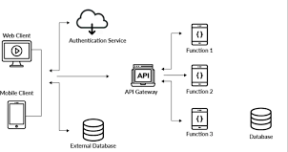

16

  - Data Flow Diagram

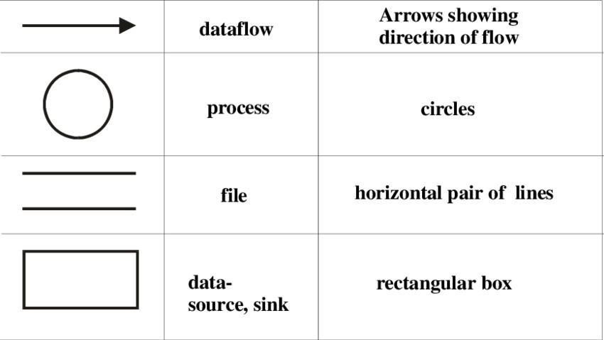

Figure 4.2.1: DFD Symbols

17

4.2.1 Data Flow Diagram

Figure 4.2.2: DFD Level (0)

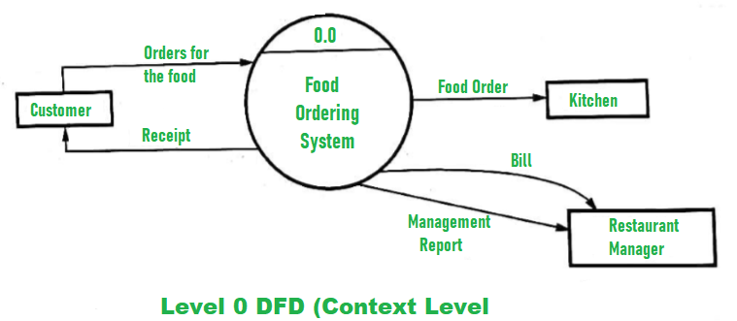

4.2 ER – Diagram

Entity-Relationship Diagrams
      - ER-modeling is a data modeling method used in software engineering to produce a conceptual data model of an information system.
      - Diagrams created using this ER-modeling method are called Entity-Relationship Diagrams or ER diagrams or ERDs.

Purpose of ERD
      - The database analyst gains a better understanding of the data to be contained in the database through the step of constructing the ERD.
      - The ERD serves as a documentation tool.
      - Finally, the ERD is used to connect the logical structure of the database to users.
      - In particular, the ERD effectively communicates the logic of the database to users.
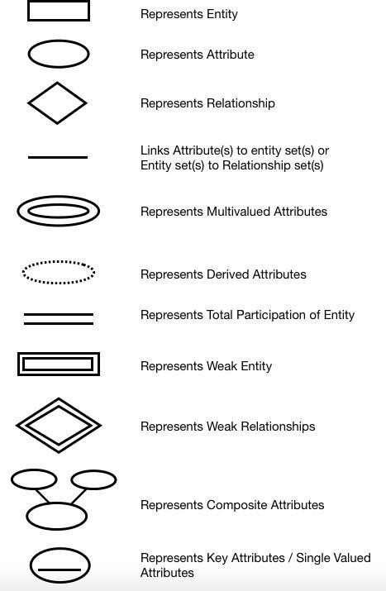

Figure 4.3.1 ER-Diagram symbols notation

20

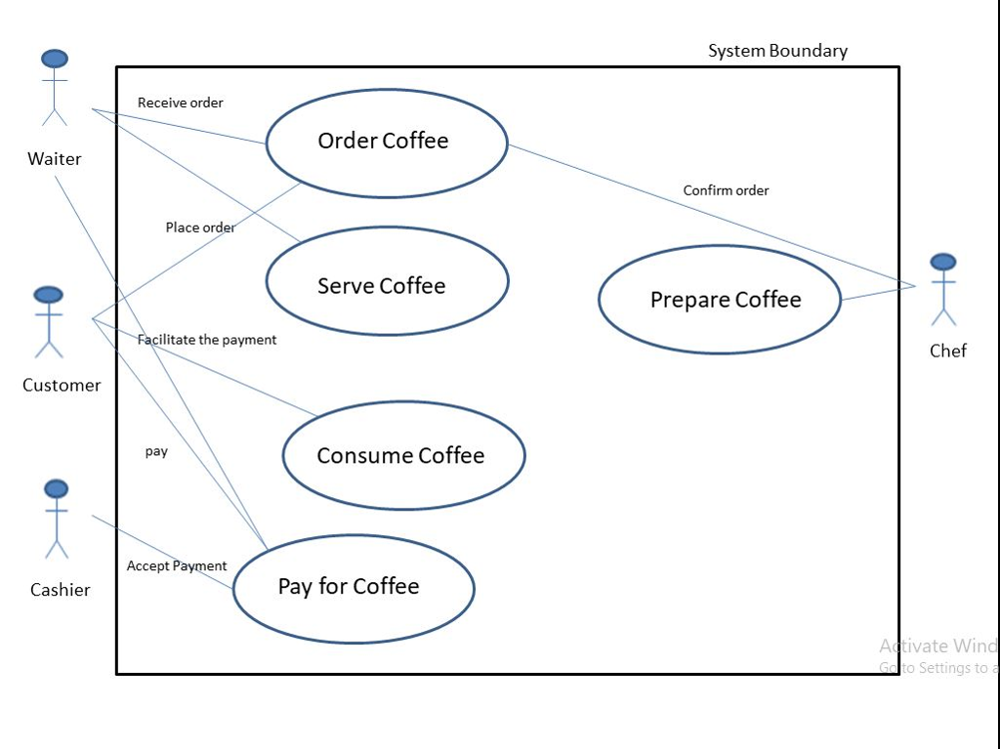

Figure 4.3.2: ER-Diagram of Cafe store

Use Case Diagram
    - A use case diagram is a graphical depiction of a user's possible interactions with a system.
    - A use case diagram shows various use cases and different types of users the system has andwill often be accompanied by other types of diagrams as well.
    - The use cases are represented by either circles or ellipses.
    - The actors are often shown as stick figures.

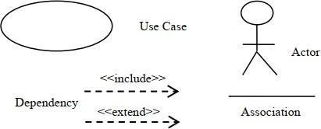

Figure 4.4.1: Use Case Diagram Symbols Notation

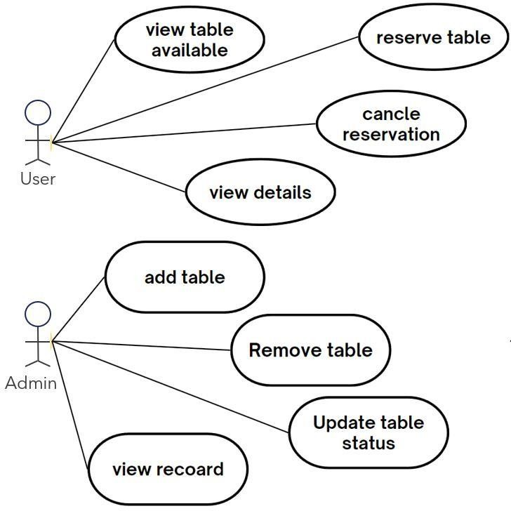

Figure 4.4.2: Use Case diagram admin and user

Activity Diagram
    - An activity in Unified Modeling Language (UML) is a major task that must take place in order to fulfill an operation contract. The Student Guide to Object-Oriented
Development defines an activity as a sequence of activities that make up a process. Activities can be represented in activity diagrams
    - An activity can represent:
    - The invocation of an operation.
    - A step in a business process.
    - An entire business process.
    - Activities can be decomposed into sub activities, until at the bottom we find atomic actions.
    - The underlying conception of an activity has changed between UML 1.5 and UML 2.0.
    - In UML 2.0 an activity is no longer based on the state-chart rather it is based on a Petri net like coordination mechanism.
    - There the activity represents user-defined behavior coordinating actions.
    - Actions in turn are pre-defined (UML offers a series of actions for this).
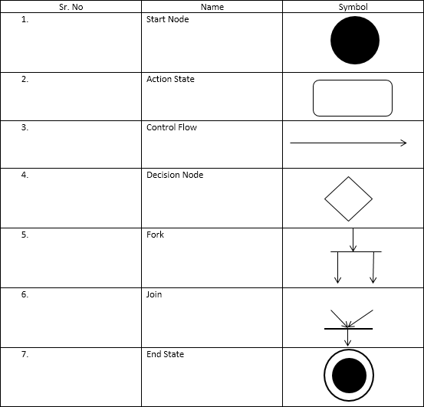
Figure 4.5.1: Activity Diagram UML notations

4.6 Class Diagram
  - In software engineering, a class diagram in the Unified Modeling Language (UML) is a type of static structure diagram that describes the structure of a system by showing the system's classes, their attributes, operations (or methods), and the relationships among objects.

  - The class diagram is the main building block of object-oriented modeling.

  - It is used for general conceptual modeling of the structure of the application, and for detailed modeling, translating the models into programming code.

  - Class diagrams can also be used for data modeling. [1]

  - The classes in a class diagram represent both the main elements, interactions in the application, and the classes to be programmed.

  - In the diagram, classes are represented with boxes that contain three compartments:

  - The top compartment contains the name of the class.

  - It is printed in bold and centered, and the first letter is capitalized.

  - The middle compartment contains the attributes of the class.

  - They are left-aligned and the first letter is lowercase.

  - The bottom compartment contains the operations the class can execute.

  - They are also left-aligned and the first letter is lowercase.

  - In the design of a system, a number of classes are identified and grouped together in a class diagram that helps to determine the static relations between them.

  - In detailed modeling, the classes of the conceptual design are often split into subclasses.

  - In order to further describe the behavior of systems, these class diagrams can be complemented by a state diagram or UML state machine.

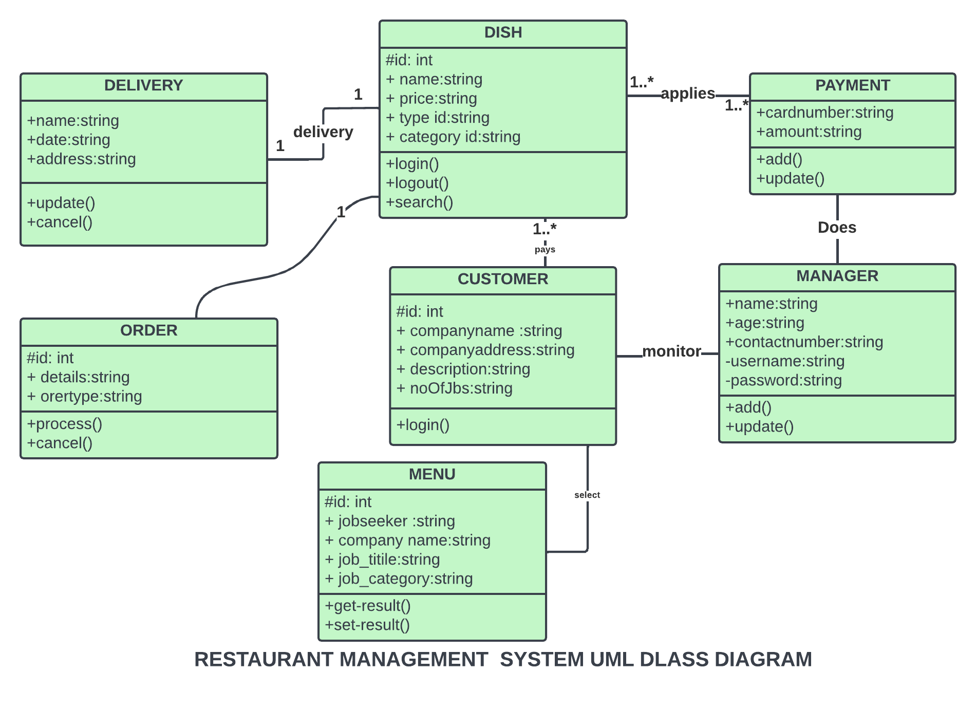

Figure 4.6.2: Class Diagram of Cafe store

\

Chapter 5

Data dictionary

Chapter:5 Data Dictionary
    - A data dictionary is a file or a set of files that includes a database's metadata.
    - The data dictionary hold records about other objects in the database, such as data ownership,data relationships to other objects, and other data.
    - The data dictionary is an essential component of any relational database.
    - Ironically, because of its importance, it is invisible to most database users.
    - Typically, only database administrators interact with the data dictionary.
Why Use a Data Dictionary?
    - Data Dictionaries are useful for a number of reasons. In short, they:
    - Assist in avoiding data inconsistencies across a project.
    - Help define conventions that are to be used across a project.
    - Provide consistency in the collection and use of data across multiple members of a researchteam.
    - Make data easier to analyze.
    - Enforce the use of Data Standards.
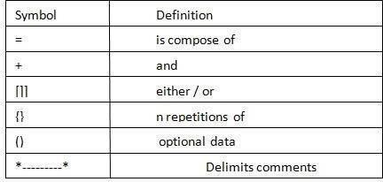

5.1 Data Dictionary Tables

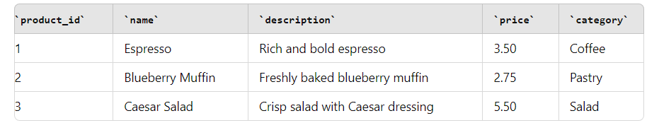

Table 5.1.1: Admin Table

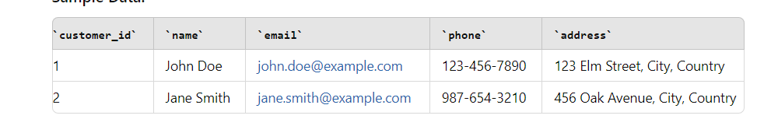

Table 5.1.3: Customers Table

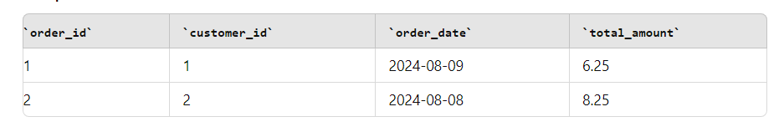

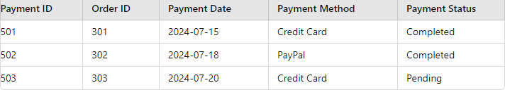

Table 5.1.5: Order details and payment details

Chapter 6 Screenshot’s

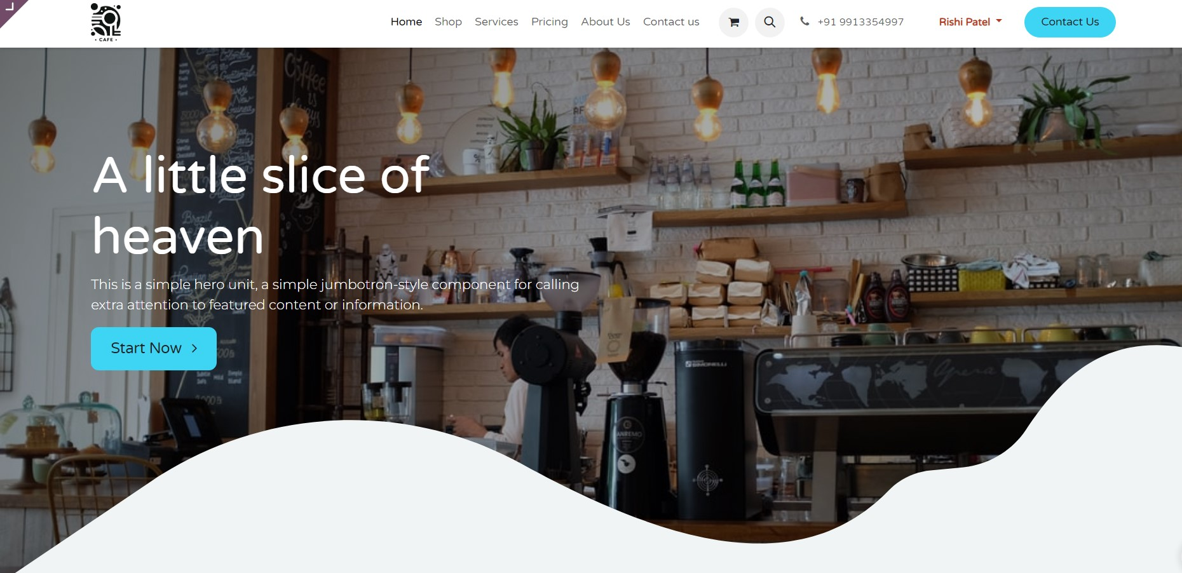

Figure 6.1 Home page



Figure 6.2 Admin Login Page

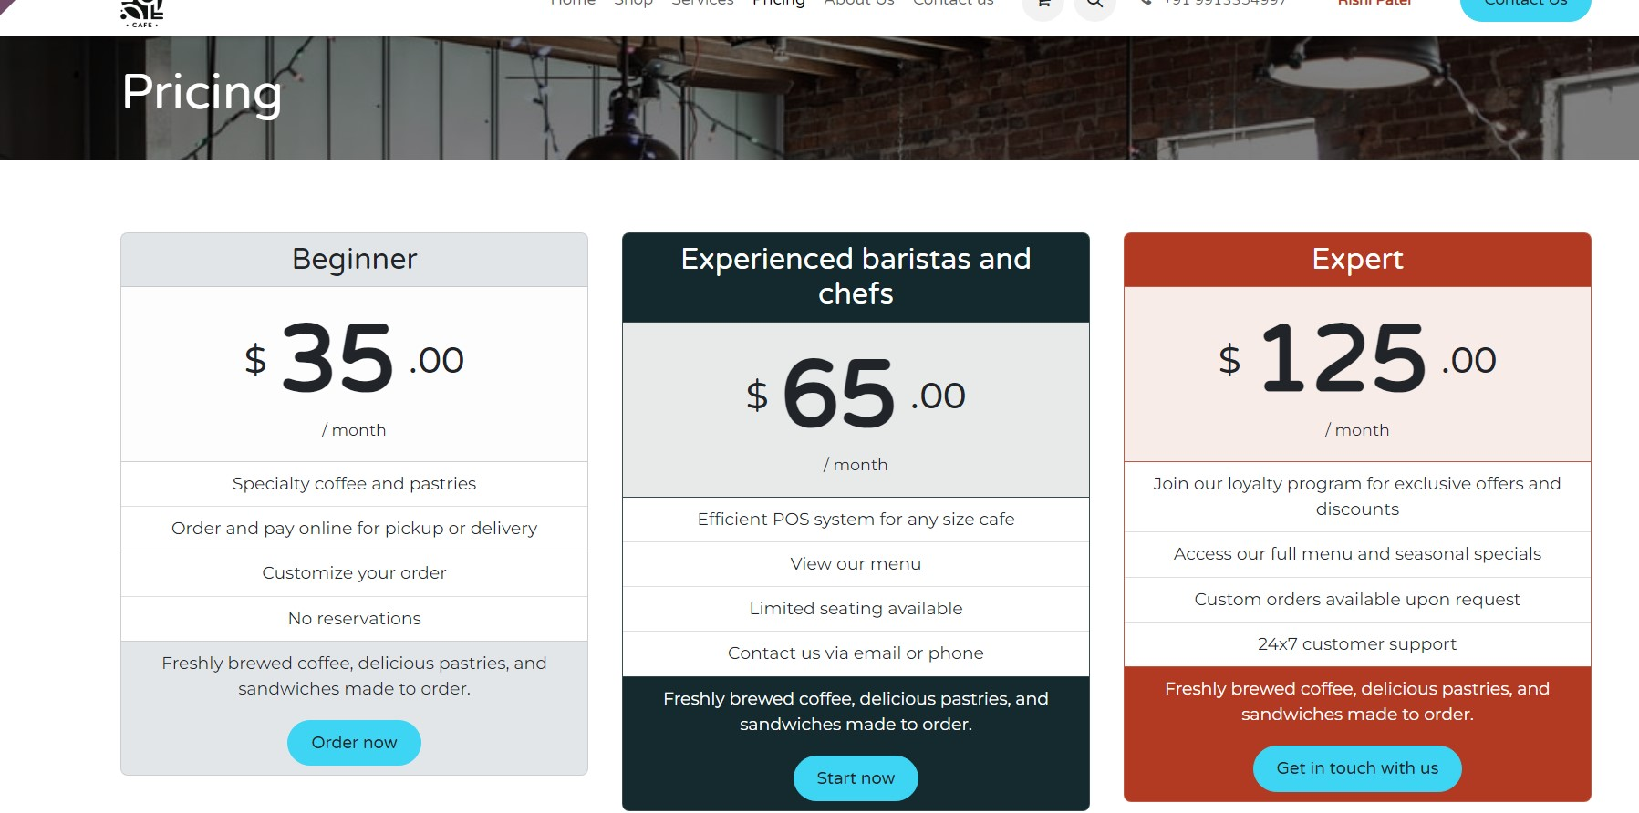

Figure 6.3 Pricing

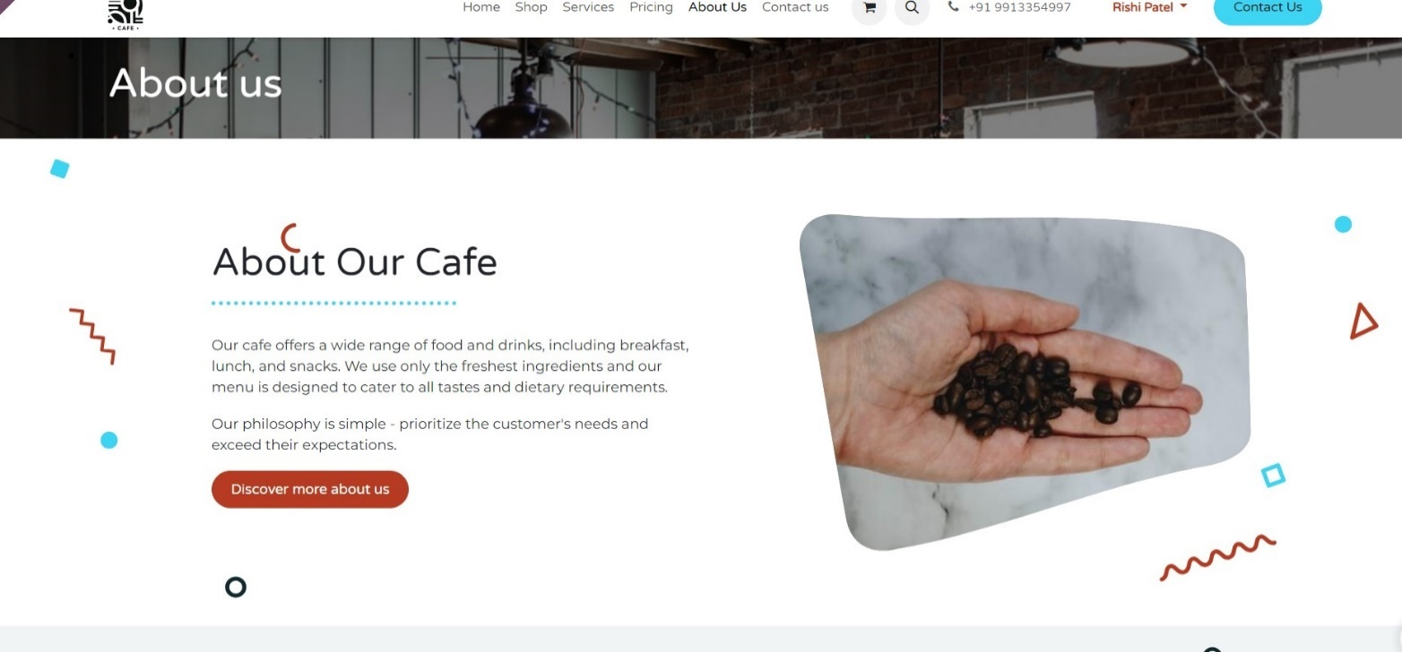

Figure 6.4 About us page

Figure 6.7 Footer

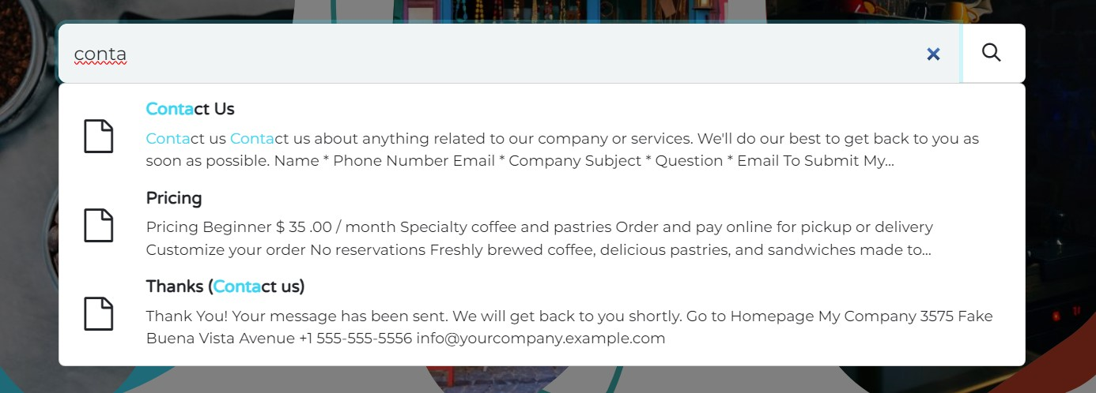

Figure 6.8 Search bar

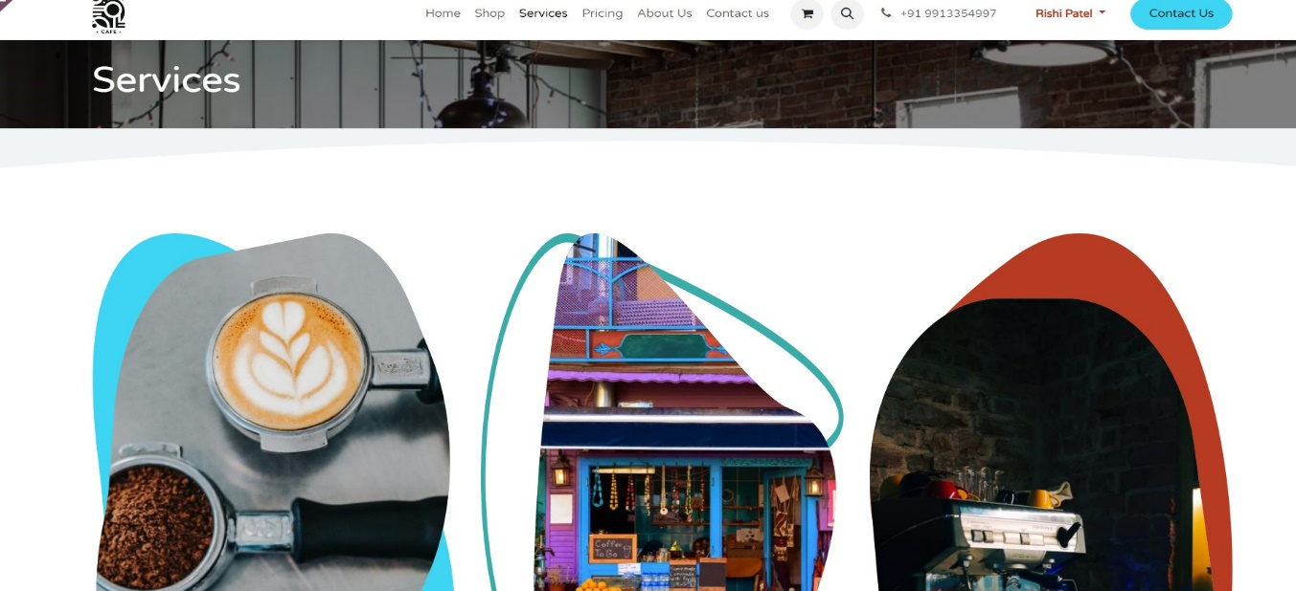

Figure 6.9 Services

Chapter 7 Conclusion

Chapter:7 Conclusion

The website is a professional online platform for selling watches, built using the Programming languages. It seamlessly integrates frontend design with robust backend functionality, offering an efficient and user-friendly eCommerce experience. The site allows for easy product management, secure transactions, and a responsive layout, ensuring a smooth shopping experience for customers. Through the website benefits from scalable and customizable features, making it a strong foundation for growing an Cafe-selling business..

